1.2.3 Exercise 15 – interchanging order of summation

Interchange the order of

$$\sum_{i=n/α}{\sum_{1≤j<i}{a_{ij}}}$$

for which *S* depends on both i and j.

Knuth says that, in principle, it is always possible to perform an interchange of order through the relation

$$\sum_{R(i)}{\sum_{S(i,j)}{a_{ij}}}=\sum_{there^{'}s a i such that R\left(i\right) and S(i,j)}{\sum_{R\left(i\right) and S(i,j)}{a_{ij}}}$$

Let’s first investigate the origin of this relation. Bellow is a graphical representation of the full domain of the sum, that can be taken also as infinite in **i** and **j** (have in mind, as Knuth advances, this rule doesn’t stand necessarily for non-convergent infinite sums).

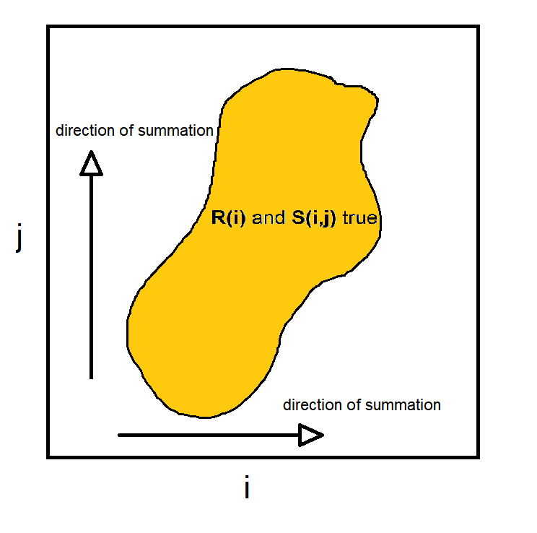

Let’s put the sum together in its more general form (still preserving the directions of summation):

$$\sum_{R(i)}{\sum_{S(i,j)}{a_{ij}}}=\sum_{R\left(i\right) and S(i,j)}{a_{ij}}$$

From there it’s possible to break it down again in some number of sub-sums, but now in terms of **j**.

$$f\left(j\right)=\sum_{R\left(i\right) and S(i,j)}{a_{ij}}$$

represents a slice of the whole domain. The whole sum then is the sum of all slices for all possible values of **j** such that there’s an **i** such that $R\left(i\right) and S\left(i,j\right)$ are true”.

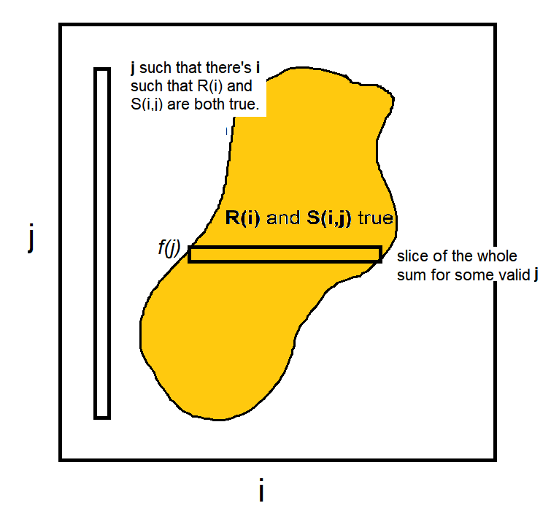

$$\sum_{R(i)}{\sum_{S(i,j)}{a_{ij}}}=\sum_{there^{'}s a i such that R\left(i\right) and S(i,j)}{f\left(j\right)}$$

$$\sum_{R(i)}{\sum_{S(i,j)}{a_{ij}}}=\sum_{there^{'}s an i such that R\left(i\right) and S(i,j)}{\left(\sum_{R\left(i\right) and S\left(i,j\right)}{a_{ij}}\right)}$$

As the first statement only involves the existence of i, it won’t depend on any specific value of it, while the second statement will likely depend on both i and j. Hence the inversion is achieved by this relation.

When the statement “ $R\left(i\right) and S\left(i,j\right)$**are true**” is subjected to the statement “there’s a value of **i**” it will be modified and yield all the conditions in which that statement is true, i.e., in this case, *all the values of* ***j*** *such that there’s an* ***i*** *such that $R\left(i\right) and S\left(i,j\right)$* ***are true.***

Let’s finally interchange the order of $\sum_{i=n/α}{\sum_{1≤j<i}{a_{ij}}}$.

In this case, using brackets notation, $\left\{\begin{aligned}R\left(i\right)=[n= αi] \\ S\left(i,j\right)=[1≤j<i]\end{aligned}\right.$.

So[there’s an i such that R(i) & S(i,j) are true] = $[1≤j<n/α]$,

and [R(i) and S(i,j) are true] = $\left\{\begin{aligned}[n= αi] \\ [j<i≤n]\end{aligned}\right.$.

Hence

$$\sum_{1≤j<n}{\sum_{\begin{aligned}j<i≤n \\ i=n/α\end{aligned}}{a_{ij}}}$$